We need to know some things about you.
There are laws to make sure your information is kept private. These laws say:
• how we can collect information

• how we store information
• who can see your information
• what we do with your information

This brochure explains how we follow those laws, respect your privacy,
and what you can do to make sure your privacy is respected.

This information is taken from the Privacy and Confidentiality Policy and Procedure. If you wish to read the entire policy, we are happy to provide a copy. Just ask us.

If we didn't respect your privacy...
Write to us:
customerservice@stayaways.com.au
Phone us:
1800 750 503

You can contact the Office of the
Australian Information Commissioner
web: www.oaic.gov.au
email: enquiries@oaic.gov.au post: GPO Box 5218
Sydney NSW 2001
phone: 1300 363 992 TTY: 133 677
Speak and Listen: 1300 555 727

Interpreters can be arranged on 131 450.

Advocates can help you complain The National Disability Advocacy Program can help you work with an advocate.
Email them at:

disabilityadvocacy@dss.gov.au
Or write to:

Disability, Employment and Carers Group
Department of Social Services
GPO Box 9820
Canberra ACT 2601
Or search "disability advocate" online.

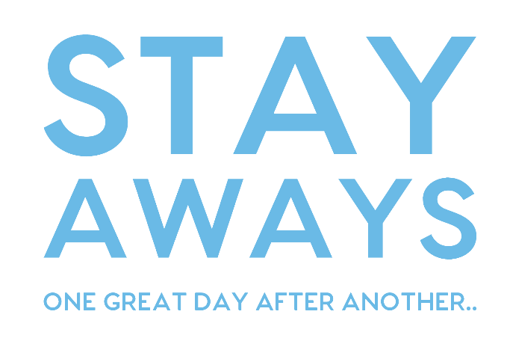

PRIVACY POLICY
Keeping your Information Safe

belongs to you safe up-to-date

Asking about you

Your personal information belongs to you.

We need your permission
to collect information about you. And to share your information.

You don't have to give permission.

Your information helps us
provide good and safe services.

We only ask for information we need. We will tell you why we need it.
That includes photos and videos too.

If you don't understand why we need information, it's OK to ask us.
Keeping it safe

We will protect your information and only use it for the right reasons, and only show the right people.

The people who work with you
need to see your information. It helps them deliver better services.

We will only share your information if:

• you give permission to share it, or

• we are very worried about your safety, or

• if the law requires us to share it.

You can see your information too. Just ask us.
Keeping it right

If your information is not correct, we may be unable to do a good job.

Give us correct information and help us keep it up-to-date.

If your personal information changes, please let us know.

Moved house? New phone number? New service provider? New contact?
— remember to tell us!

We will also check your information regularly and update it.

